**Project Screen Flow**

* + Welcome screen
    - First screen
      * 1(Login Screen)
      * 1.1 (Candidate Management)
        + 1.1.1 (Add New Candidate)
        + 1.1.2 (View All Candidate)
        + 1.1.3 (Search a Candidate)
        + 1.1.4 (Update a Candidate Data)
        + 1.1.5(Return to Main Menu)
      * 1.2 (Voter Management)
        + 1.2.1 (Add New Voter)
        + 1.2.2 (View All Voter)
        + 1.2.3 (Search a Voter)
        + 1.2.4 (Update a Voter Data)
        + 1.2. (Return to Main Menu)
      * 1.3(Election Voting)
        + 1.3.1(Voter Login)
        + 1.3.2(Cast the Vote)
      * 1.4(Result)
        + 1.4.1(Voter count)
        + 1.4.2(Winner Candidate)
      * 1.5 (Change Password)
      * 1.6 (Logout)

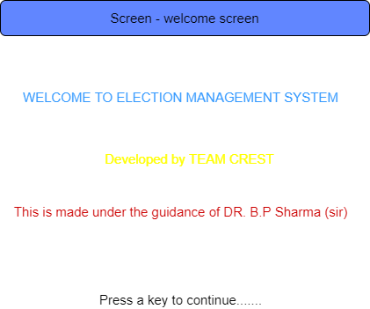

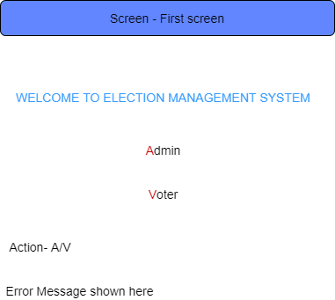

1

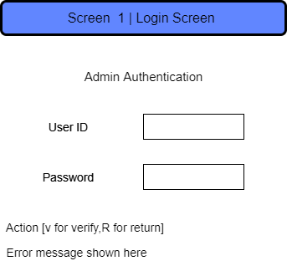

1.1

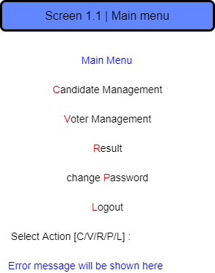

1.1.1

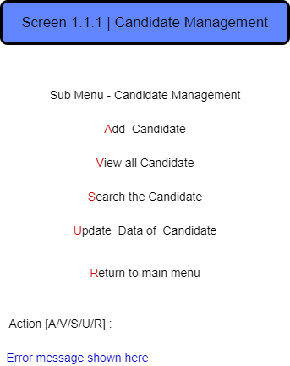

1.1.1.1

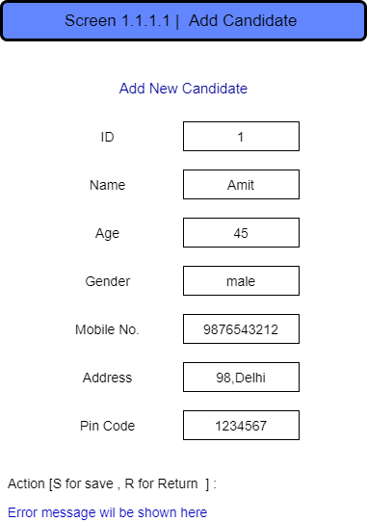

1.1.1.2

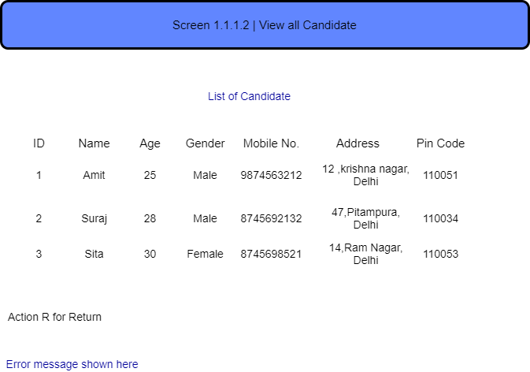

1.1.1.3

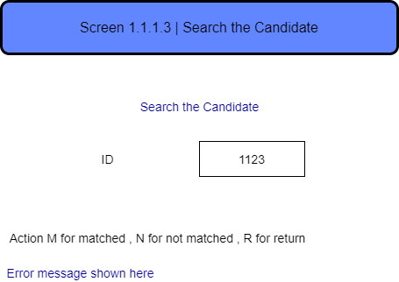

1.1.1.4

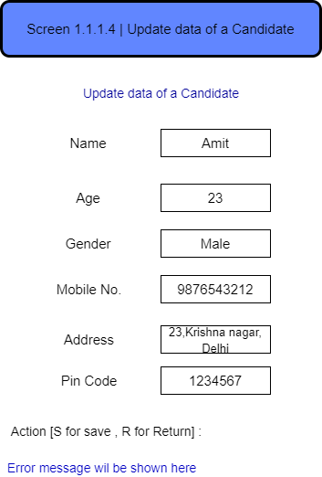

1.2.1

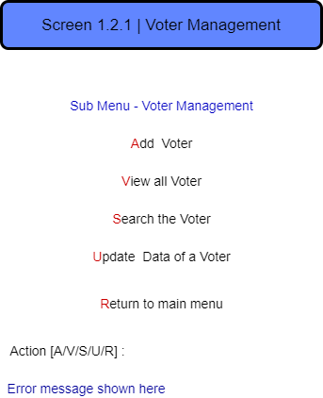

1.2.1.1

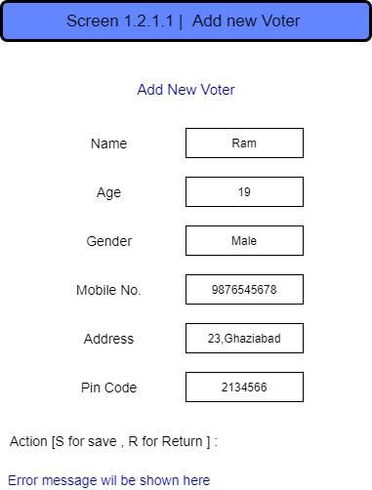

1.2.1.2

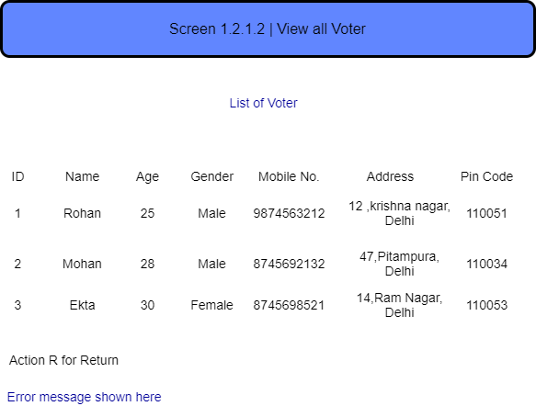

1.2.1.3

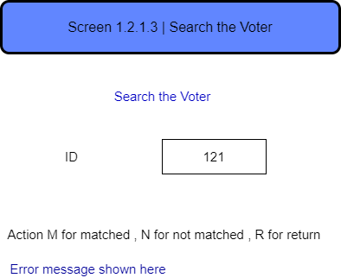

1.2.1.4

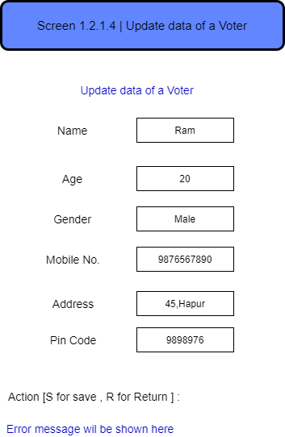

1.3.1

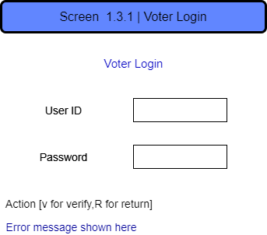

1.3.2

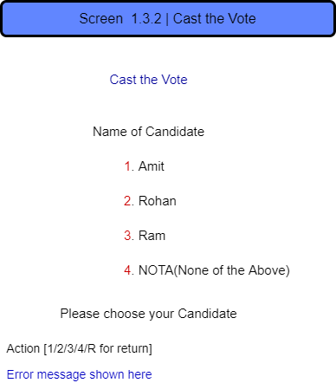

1.4

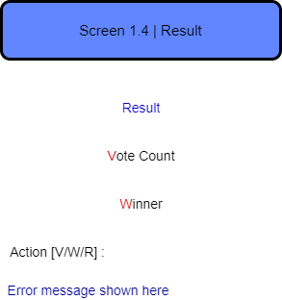

1.4.1

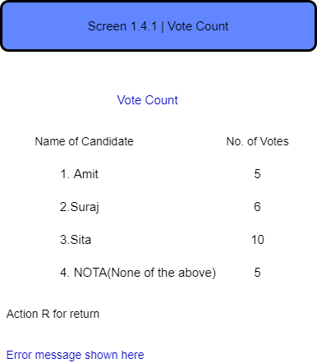

1.4.2

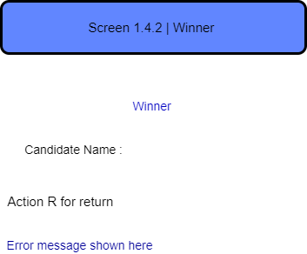

1.5

